Local Attractions
Alhambra Theatre
Audiences in the 780-seat proscenium theatre enjoy this renovated theater with expansions, comfort, and restored molding that is patterned after the original 1928 styling. An annual Live at the Alhambra series offers a variety of shows and musical performances presented by the Pennyroyal Arts Council. The Alhambra now features showings of classic films.

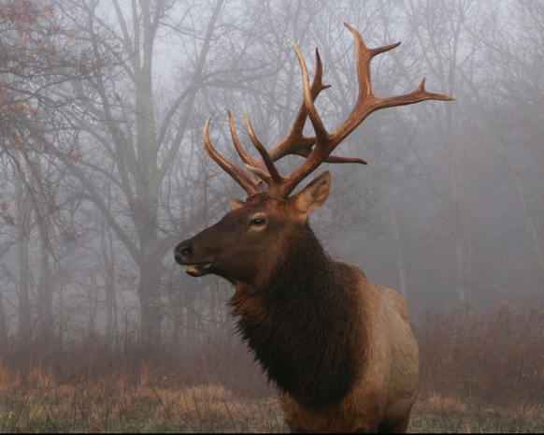
Pennyroyal Scuba Blue Springs Resort
Pennyroyal Scuba Blue Springs Resort is a diver exclusive destination for dive training and adventure diving. With a breathtaking 22 acre former limestone quarry and unusually clear spring fed water, Blue Springs offers divers a wide range of adventure. From open water divers to technical diving, Blue Springs is the Prime Diving Destination in Kentucky and one of the top sites in the Mid-West.
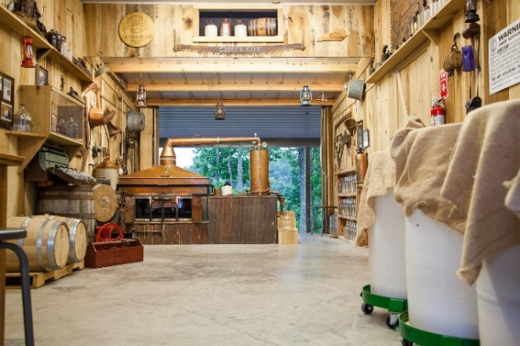

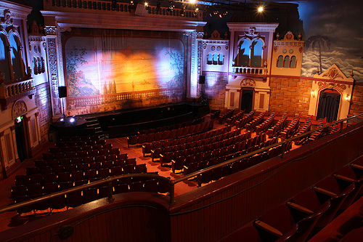
Land Between the Lakes
Access over 300 miles of undeveloped shoreline, 200 miles of paved roads, 500 miles of trails, and 170,000 acres of forests and open lands. Additionally, visit park attractions: the Elk and Bison Prairie, Homeplace 1850s Farm, the Woodlands Nature Station, and the planetarium and observatory.

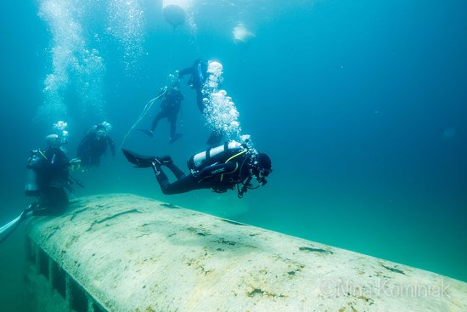
Casey Jones Distillery
Crafting true corn whisky in the tradition of Golden Pond, KY using an authentic Casey Jones Still at Casey Jones Distillery. Join them Fridays & Saturdays for tours and tastings, shop awhile in Casey's Corner, relax out back on the porch, or bring your fishing pole and try your luck in the lake
Local Eats
Horseshoe Steak House
Steakhouse, $$-$$$
2112 Fort Campbell Blvd
Hopkinsville, KY 42240

Davo’s Burgers and Fries
Burgers, $
3115 Canton Pike
Hopkinsville, KY 42240

Ferrell’s Snappy Service
Burgers, $
1001 S Main St
Hopkinsville, KY 42240

Woodshed Pit Bar-B-Que
Barbecue, $
1821 W 7th St
Hopkinsville, KY 42240

Da Vinci’s Little Italian
Italian, $$-$$$
304 North Dr
Hopkinsville, KY 42240

Osaka
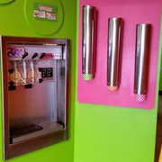
Japanese, $$-$$$
2602 Fort Campbell Blvd
Hopkinsville, KY 42240-4939

Senor Lopez
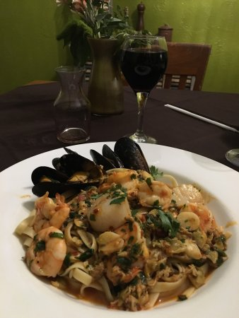
Mexican, $$-$$$
125 Turtle Crk
Hopkinsville, KY 42240-8710

El Bracero
Mexican, $$-$$$
200 Richard Mills Dr
Hopkinsville, KY 42240

Taco Express Restaurante
Mexican, $
1115 N Main St
Hopkinsville, KY 42240

Tangy Roots
Frozen Yogurt, $
2711 Fort Campbell Blvd
Hopkinsville, KY 42240

Whistlestop Donuts
Donuts
420 E 9th St
Hopkinsville, KY 42240

Hopkinsville Donuts
Donuts
420 E 9th St
Hopkinsville, KY 42240

The Corner Coffeehouse
Coffee
707 S Virginia St
Hopkinsville, KY 42240

Hopkinsville Brewing Company
Brewery
102 E 5th St
Hopkinsville, KY 42240
